

STANDARD CONTAINER DETAILS 20' GENERAL PURPOSE / DRY VAN

 |  |  | Millimeters | Feet
 | Internal | Length | 5'900 | 19'4''
 | Dimensions | Width | 2'350 | 7'8''
 |  | Height | 2'390 | 7'10''
 | Door Opening | Width | 2'340 | 7'8''
 |  | Height | 2'280 | 7'6''
 |  |  | Kilograms | Lbs
 | Weight | Max. Payload | 21'800 | 48'060
 |  | Container- | 2'200 | 4'850
 |  | Tare | 2'200 | 4'850
 |  | Max . Gross | 24'000 | 52'910
 |  | Wt. | 24'000 | 52'910
 |  |  | Cube | Cube
 |  |  | Meters | Feet
 | Volume Capacity | Max. Payload | 33,2 | 1173
40' GENERAL PURPOSE / DRY VAN
 |  |  | Millimeters | Feet
 | Internal | Length | 12'033 | 39'6''
 | Dimensions | Width | 2'350 | 7'8''
 |  | Height | 2'390 | 7'10''
 | Door Opening | Width | 2'340 | 7'8''
 |  | Height | 2'280 | 7'6''
 |  |  | Kilograms | Lbs
 | Weight | Max. Payload | 26'680 | 58'820
 |  | Container- | 3'800 | 8'380
 |  | Tare | 3'800 | 8'380
Suitable for commodities in boxes, cartons, bundles, drums, |  | Tare
 |  | Max . Gross
smaller cases, furniture’s, pallets, etc. |  | Max . Gross | 30'480 | 67'200
 |  | Wt. | 30'480 | 67'200
 |  |  | Cube | Cube
 |  |  | Meters | Feet
 | Volume Capacity | Max. Payload | 67,6 | 2'387
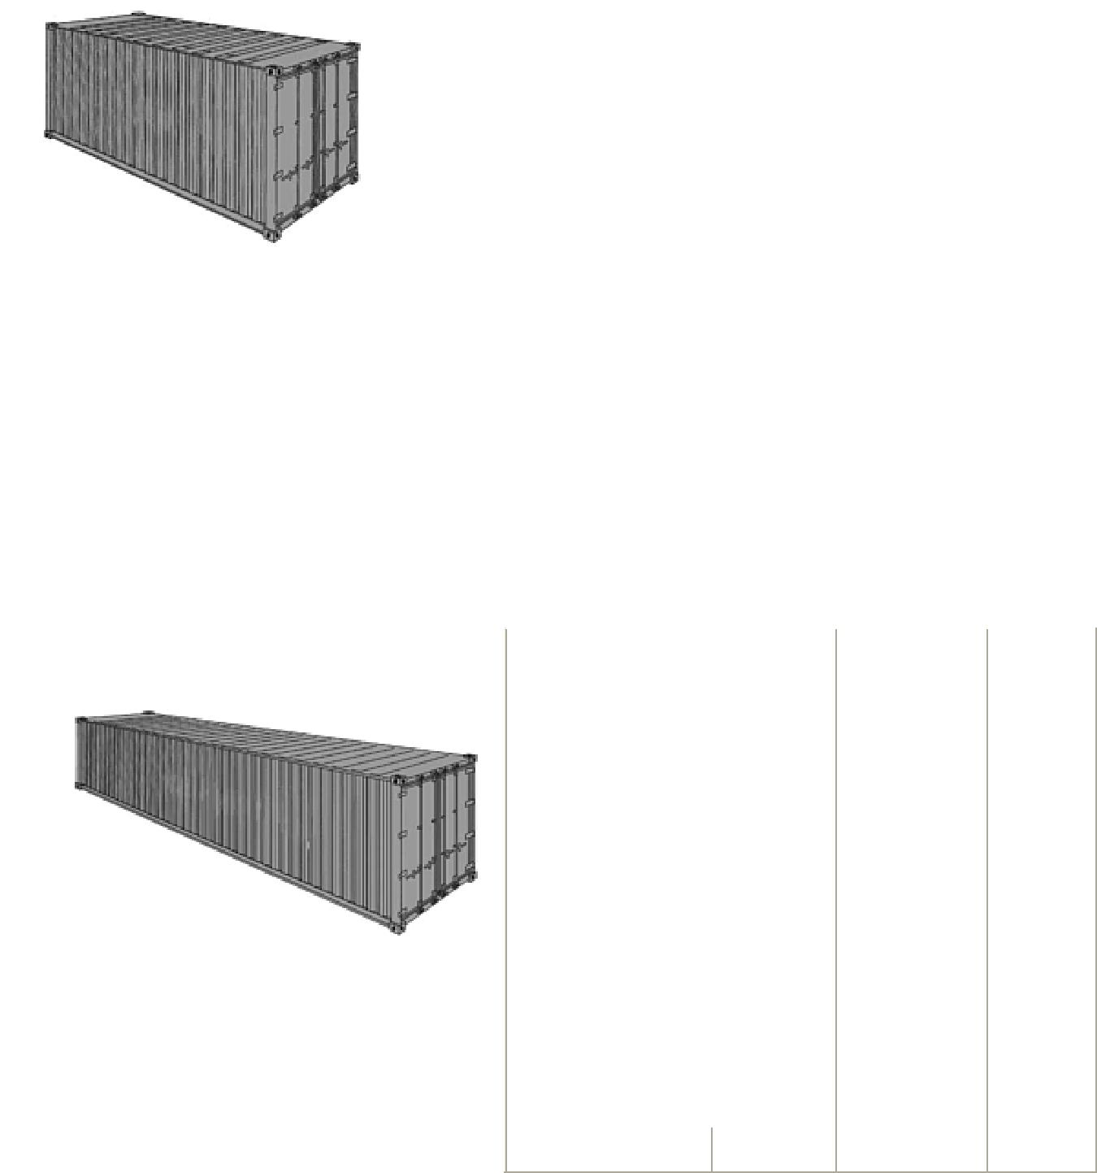
• Internal dimensions and weights are based on shipping line's and manufacturer's specifications. Tolerances must always be taken into account by shipper. Above mentioned details are to be considered as a guideline only.

• Weight restrictions may be considered throughout the whole transport leg. National rules and regulations for road and rail transport, capacity limitations of cranes in seaport and inland-terminals as well as other factors may overrule the possible payload of a container.

• For precise case-by-case information consult your local Freight Forwarder, Packaging Specialist or the specific shipping line you are going to book with.

OPEN TOP CONTAINER DETAILS

20' OPEN TOP
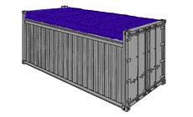
 |  |  | Millimetres | Feet
 | Internal | Length | 5'895 | 19'4''
 | Dimensions | Width | 2'344 | 7'8''
 |  | Height | 2'347 | 7'8''
 | Door | Width | 2'336 | 7'8''
 | Opening | Height | 2'160 | 7'1''
 | Roof | Width | 5'335 | 17'6''
 | Opening | Height | 1'900 | 6'2''
 |  |  | Kilograms | Lbs
 | Weight | Max. | 28'130 | 62'020
 |  | Payload
 |  | Container- | 2'350 | 5'180
 |  | Tare | 2'350 | 5'180
 |  | Max . Gross | 30'480 | 67'200
 |  | Wt.
 |  |  | Cube | Cube
 |  |  | Metres | Feet
 | Volume | Max. | 31,5 | 1'112
 |  | Payload
40' OPEN TOP
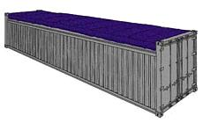

For large and/or high pieces that can not be loaded through container doors, such as machineries, marble, glass sheets, etc

 |  | Millimetres | Feet
Internal | Length | 12'022 | 39'5''
Dimensions | Width | 2'344 | 7'8''
 | Height | 2'347 | 7'8''
Door | Width | 2'336 | 7'8''
Opening | Height | 2'275 | 7'5''
Roof | Width | 11'515 | 37'9''
Opening | Height | 1'880 | 6'2''
 |  | Kilograms | Lbs
Weight | Max. | 26'740 | 58'955
 | Payload
 | Container- | 3'740 | 8'245
 | Tare | 3'740 | 8'245
 | Max . Gross | 30'480 | 67'200
 | Wt.
 |  | Cube | Cube
 |  | Metres | Feet
Volume | Max. | 65,4 | 2'306
Capacity | Payload | 65,4 | 2'306

- Internal dimensions and weights are based on shipping line's and manufacturer's specifications. Tolerances must always be taken into account by shipper. Above mentioned details are to be considered as a guideline only.

- Weight restrictions may be considered throughout the whole transport leg. National rules and regulations for road and rail transport, capacity limitations of cranes in seaport and inland-terminals as well as other factors may overrule the possible payload of a container.

- For precise case-by-case information consult your local Freight Forwarder, Packaging Specialist or the specific shipping line you are going to book with.

FLAT RACK CONTAINER SPECIFICATION:
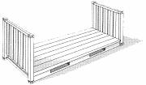

FLAT RACK 20'

inside | inside | inside | door | door | capacity | tare | maxi
length | width | height | width | height | capacity | weight | cargo
18'5" | 7'3" | 7'4" | - | - | - | 5,578 Lbs | 47,333 Lbs
5.620 m | 2.200 m | 2.233 m | - | - | - | 2,530 Kgs | 21,470 Kgs

FLAT RACK 40'

inside | inside | inside | door | door | capacity | tare | maxi
length | width | height | width | height | capacity | weight | cargo
39'7" | 6'10" | 6'5" | - | - | - | 12,081 Lbs | 85,800 Lbs
12.080 m | 2.438 m | 2.103 m | - | - | - | 5,480 Kgs | 39,000 Kgs
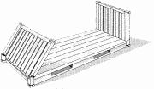

FLAT RACK COLLAPSIBLE CONTAINERS

FLAT RACK COLLAPSIBLE 20'

inside | inside | inside | door | door | capacity | tare | maxi
length | width | height | width | height | capacity | weight | cargo
18'6" | 7'3" | 7'4" | - | - | - | 6,061 Lbs | 61,117 Lbs
5.618 m | 2.208 m | 2.233 m | - | - | - | 2,750 Kgs | 27,730 Kgs

FLAT RACK COLLAPSIBLE 40' (STAK BED)

inside | inside | inside | door | door | capacity | tare | maxi
length | width | height | width | height | capacity | weight | cargo
39'7" | 6'10" | 6'5" | - | - | - | 12,787 Lbs | 85,800 Lbs
12.080 m | 2.126 m | 2.043 m | - | - | - | 5,800 Kgs | 39,000 Kgs

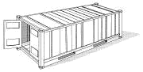

REEFER CONTAINERS

REEFER 20'
inside |  | inside |  |  | inside |  |  | door |  | door |  |  |  | capacity |  |  |  |  |  |  |  | tare |  |  | maxi
length |  | width |  |  | height |  |  | width |  | height |  |  |  |  |  |  |  |  |  |  | weight |  |  |  | cargo
17'8" |  | 7'5" |  |  | 7'5" | 7'5" |  |  | 7'3" |  |  |  |  | 1,000 Cft |  |  |  |  |  |  | 7,040 Lbs |  |  |  | 45,760 Lbs
5.425 m |  | 2.275 m |  |  | 2.260 m |  |  | 2.258 m |  | 2.216 m |  |  |  | 28.3 Cu.m |  |  |  |  |  |  | 3,200 Kgs |  |  |  | 20,800 Kgs
REEFER 40'
inside |  | inside |  |  | inside |  |  | door |  | door |  |  |  | capacity |  |  |  |  |  |  |  | tare |  |  | maxi
length |  | width |  |  | height |  |  | width |  | height |  |  |  |  |  |  |  |  |  |  | weight |  |  |  | cargo
37'8" |  | 7'5" |  |  | 7'2" |  | 7'5" |  | 7'0" |  |  |  |  | 2,040 Cft |  |  |  |  | 10,780 Lbs |  |  |  |  |  | 56,276 Lbs
11.493 m |  | 2.270 m |  |  | 2.197 m |  |  | 2.282 m |  | 2.155 m |  |  |  | 57.8 Cu.m |  |  |  |  |  |  | 4,900 Kgs |  |  |  | 25,580 Kgs
REEFER 40' HIGH CUBE
inside |  | inside |  |  | inside |  |  | door |  | door |  |  |  | capacity |  |  |  |  |  |  |  | tare |  |  | maxi
length |  | width |  |  | height |  |  | width |  | height |  |  |  |  |  |  |  |  |  |  | weight |  |  |  | cargo
37'11" |  | 7'6" |  |  | 8'2" |  |  | 7'6" |  | 8'0" |  |  |  | 2,344 Cft |  |  |  |  |  |  | 9,900 Lbs |  |  |  | 57,561 Lbs
11.557 m |  | 2.294 m |  |  | 2.500 m |  |  | 2.294 m |  | 2.440 m |  |  |  | 66.6 Cu.m |  |  |  |  |  |  | 4,500 Kgs |  |  |  | 25,980 Kgs
 |  |  |  |  | 40' HIGH CUBE GENERAL PURPOSE / DRY VAN
 |  |  |  |  |  |  |  |  |  |  |  |  |  |  |  |  |  |  |  |  |  |  | Millimeters |  |  | Feet
 |  |  |  |  |  |  |  |  |  |  | Internal |  |  |  |  | Length |  |  |  |  |  |  | 12'033 |  |  | 39'6''
 |  |  |  |  |  |  |  |  |  |  | Dimensions |  |  |  |  | Width |  |  |  |  |  |  | 2'350 |  |  | 7'8''
 |  |  |  |  |  |  |  |  |  |  |  |  |  |  |  | Height |  |  |  |  |  |  | 2'695 |  |  | 8'10''
 |  |  |  |  |  |  |  |  |  |  | Door Opening |  |  |  |  | Width |  |  |  |  |  |  | 2'340 |  |  | 7'8''
 |  |  |  |  |  |  |  |  |  |  |  |  |  |  |  | Height |  |  |  |  |  |  | 2'585 |  |  | 8'6''
 |  |  |  |  |  |  |  |  |  |  |  |  |  |  |  |  |  |  |  |  |  |  | Kilograms |  |  | Lbs
Suitable for commodities in boxes, cartons, bundles, drums, |  |  |  |  |  |  |  |  |  |  | Weight |  |  |  |  | Max. |  |  |  |  |  |  | 26'480 |  |  | 58'360
 |  |  |  |  |  |  |  |  |  |  |  |  |  |  |  | Payload
smaller cases, furniture’s, pallets, etc. |  |  |  |  |  |  |  |  |  |  |  |  |  |  |  | Container- |  |  |  |  |  |  | 4'000 |  |  | 8'850
 |  |  |  |  |  |  |  |  |  |  |  |  |  |  |  | Tare |  |  |  |  |  |  | 4'000 |  |  | 8'850
 |  |  |  |  |  |  |  |  |  |  |  |  |  |  |  | Max . Gross |  |  |  |  |  |  | 30'480 |  |  | 67'200
 |  |  |  |  |  |  |  |  |  |  |  |  |  |  |  | Wt. |  |  |  |  |  |  | 30'480 |  |  | 67'200
 |  |  |  |  |  |  |  |  |  |  |  |  |  |  |  |  |  |  |  |  |  |  | Cube |  |  | Cube
 |  |  |  |  |  |  |  |  |  |  |  |  |  |  |  |  |  |  |  |  |  |  | Meters |  |  | Feet
 |  |  |  |  |  |  |  |  |  |  | Volume |  |  |  |  | Max. |  |  |  |  |  |  | 76,2 |  |  | 2'690
 |  |  |  |  |  |  |  |  |  |  | Capacity |  |  |  |  | Payload |  |  |  |  |  |  | 76,2 |  |  | 2'690
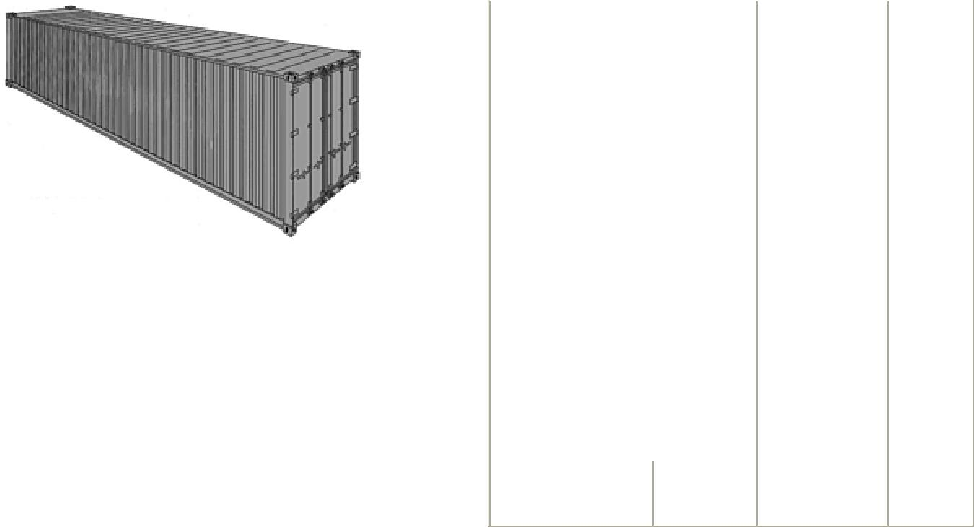
- Internal dimensions and weights are based on shipping line's and manufacturer's specifications. Tolerances must always be

taken into account by shipper. Above mentioned details are to be considered as a guideline only.

- Weight restrictions may be considered throughout the whole transport leg. National rules and regulations for road and rail transport, capacity limitations of cranes in seaport and inland-terminals as well as other factors may overrule the possible payload of a container.

- For precise case-by-case information consult your local Freight Forwarder, Packaging Specialist or the specific shipping line you are going to book with.
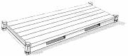

PLATFORM CONTAINERS

PLATFORM 20'

inside | inside | payload | door | door | capacity | tare | maxi
length | width | height | width | height | capacity | weight | cargo
19'11" | 8'0" | 7'4" | - | - | - | 6,061 Lbs | 52,896 Lbs
6.058 m | 2.438 m | 2.233 m | - | - | - | 2,750 Kgs | 24,000 Kgs

PLATFORM 40'

inside | inside | payload | door | door | capacity | tare | maxi
length | width | height | width | height | capacity | weight | cargo
40'00" | 8'0" | 6'5" | - | - | - | 12,783 Lbs | 86,397 Lbs
12.18 m | 2.40 m | 1.95 m | - | - | - | 5,800 Kgs | 39,200 Kgs

